Lunch SAP logon and select Q4T then click
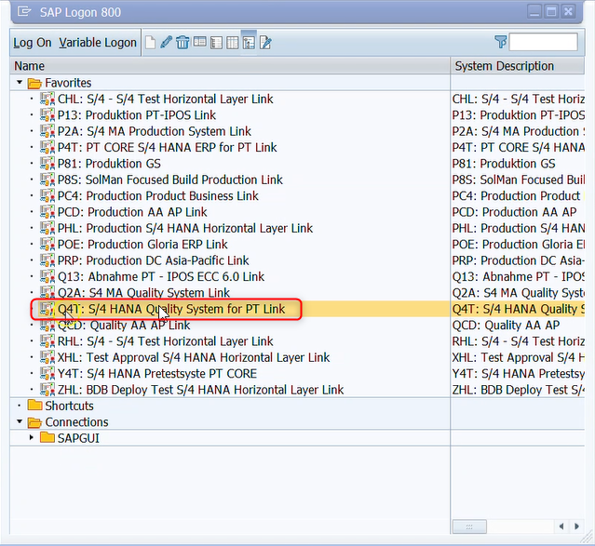

TCode: Enter ‘VF03’ and hit ‘Enter’
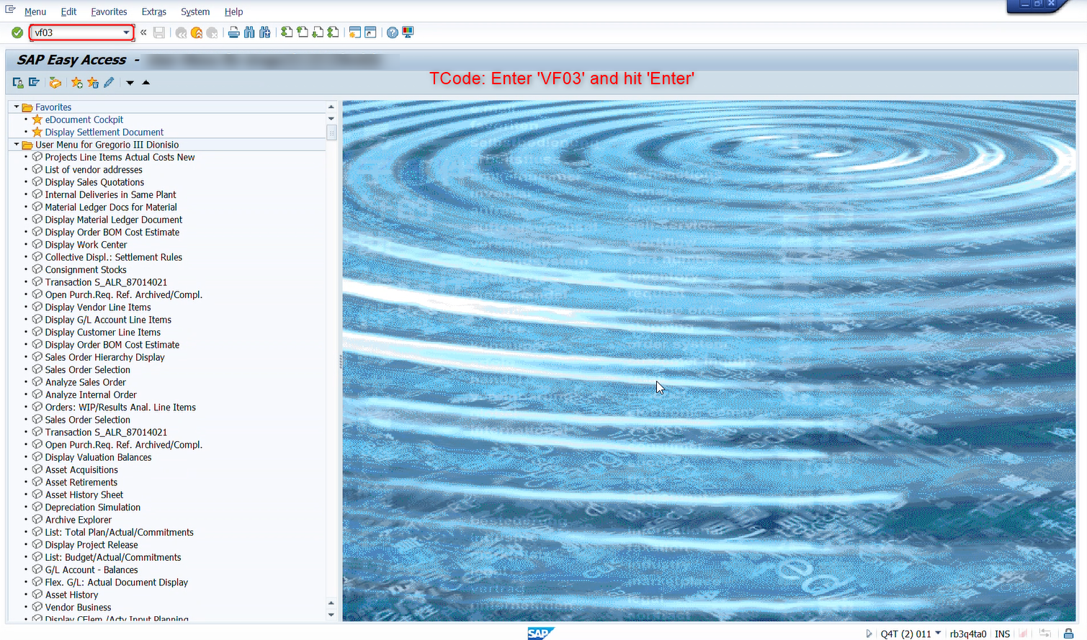
- Billing document: Key BX00000063’ and hit ‘Enter’
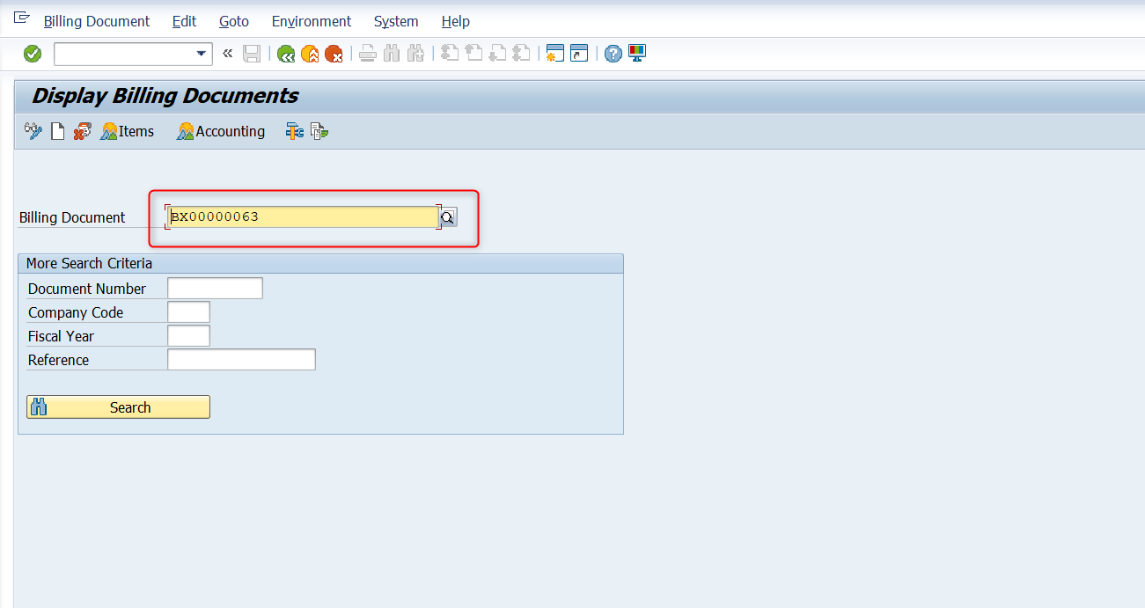

- Click ‘Billing Document’
- Go-to ‘Issue Output to’ and click
- Print preview will display.
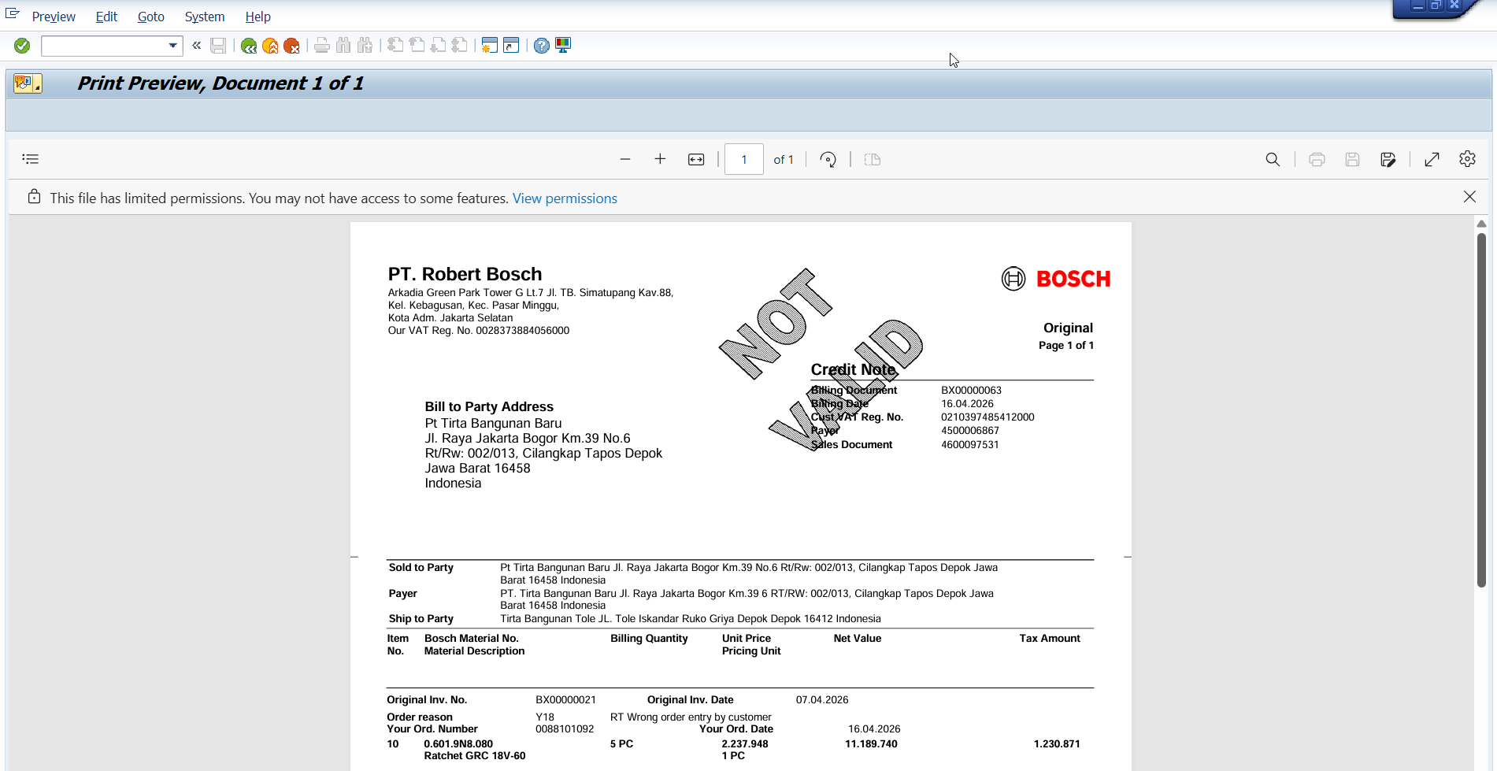
- Scroll down to show the amount
- Showing the billing amount
- Click to create new SAP window
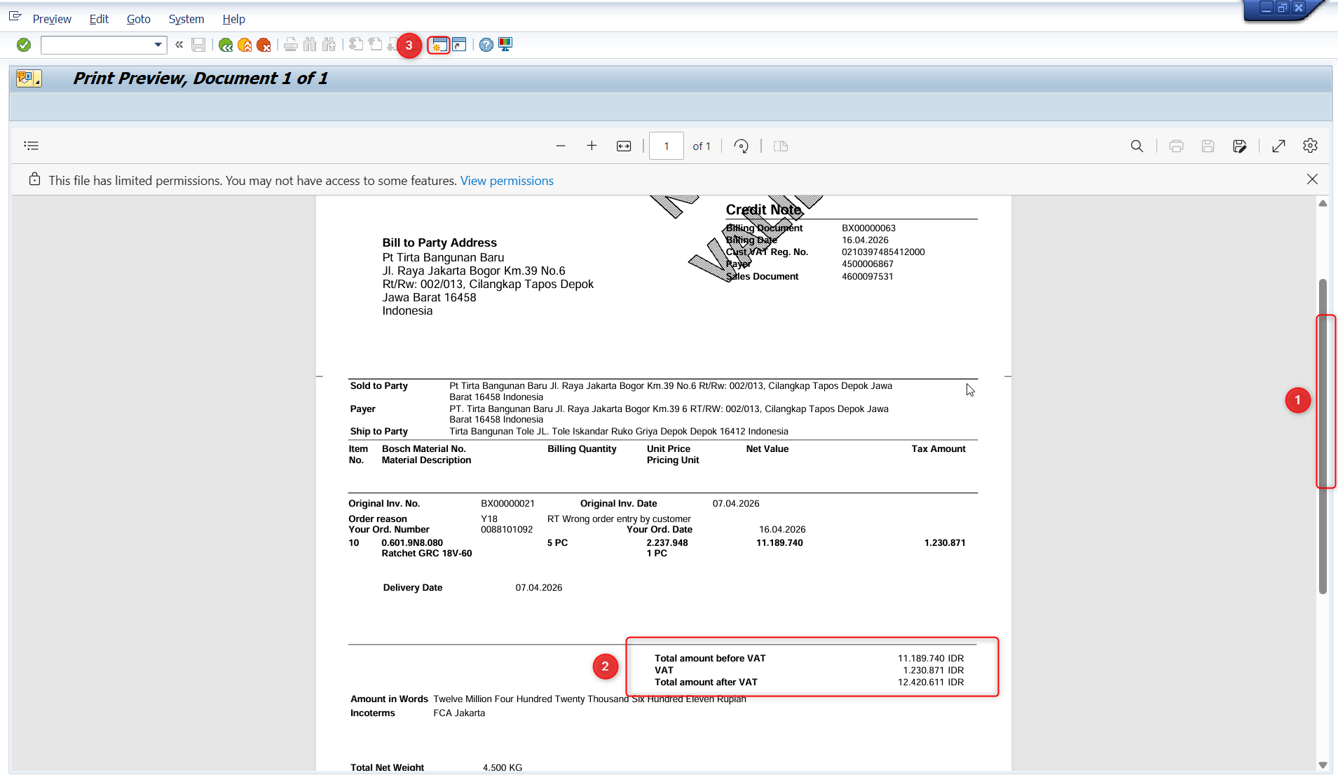
In the new SAP window, Enter VF03 and hit ‘Enter’

Input again the billing document ‘BX00000063’ and hit ‘Enter’
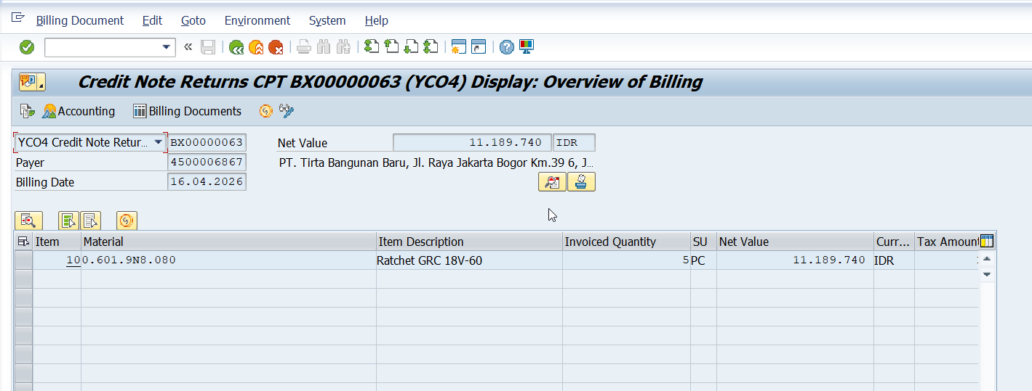

- Click ‘Environment’
- Select ‘Document Flow’ and click.
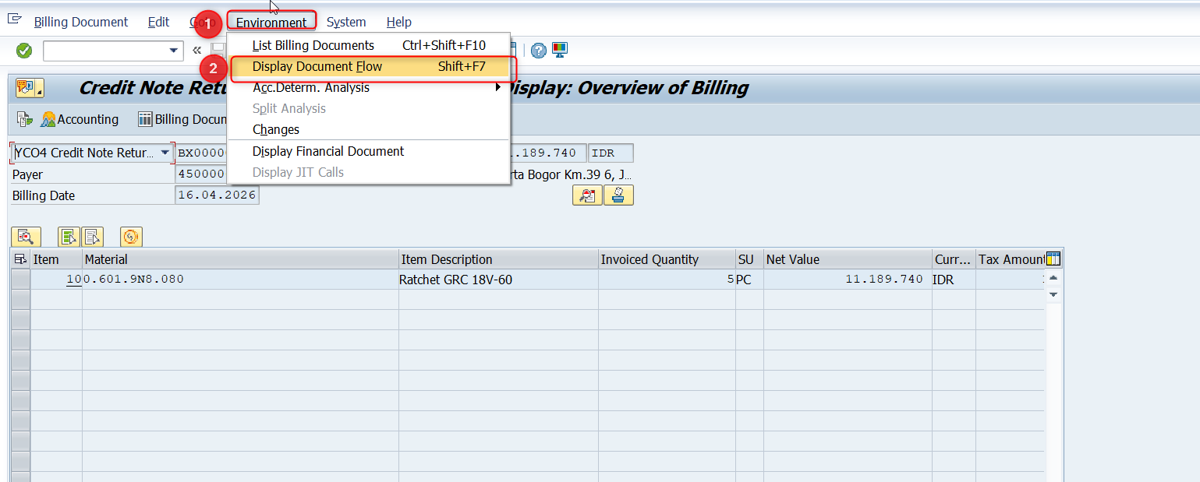
- Select the Central Finance document
- Click Display Document
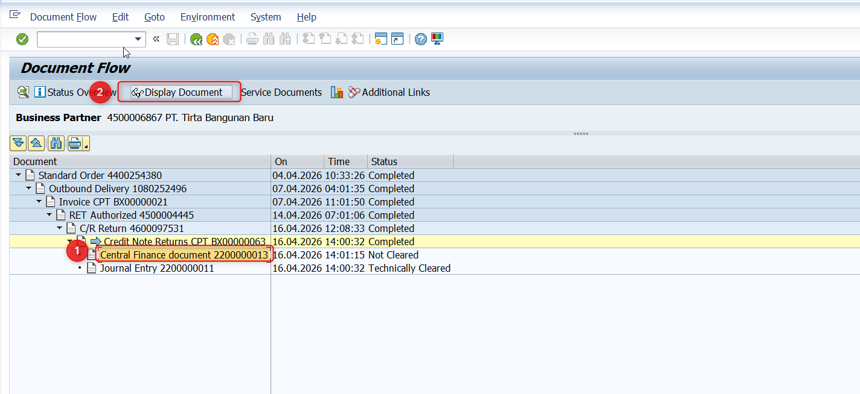

Screenshot and compare GL account posting.
Compare with GL below.
5010100003
4610360000
